The Use of Informal Assessment Measures When Testing Students of All Ages

Presented By:

Gina England MA, CCC-SLP
Speech and Language Pathologist

geseminars@gmail.com

ginaenglandseminars.com

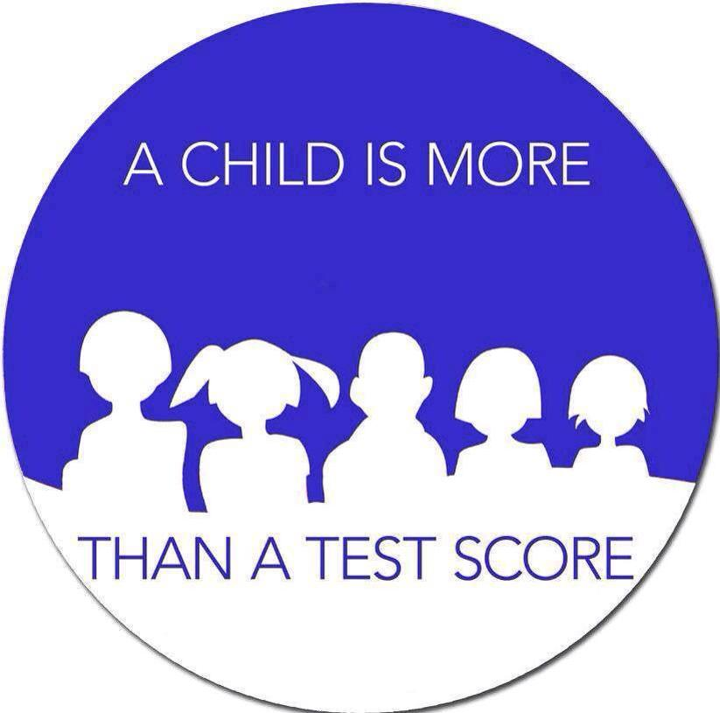

Learner Outcomes:

1. Identify the language required to support your use of informal assessment
Measures using ASHA’s position statement and IDEA law.
2. Evaluate challenging students through enhanced student engagement.
3. Assemble a new diagnostic toolbox of functional informal assessments.
4. State a new approach to assessing academic vocabulary.
5. Expand your collaboration with peers and families via rating scales.
6. Individualize and personalize your student’s assessment plans
7. Verbalize what constitutes observational data and its value in your assessments.

ASHA Practice Portal > Documentation in Schools
https://www.asha.org/practice-portal/professional-issues/documentation-in-schools/#collapse_1

Multidisciplinary Evaluation and Assessment

IDEA (2004) requires that an evaluation be comprehensive and assess all areas of suspected disability. It is important for the clinician to involve other assessment staff as part of the multidisciplinary evaluation team to address educational and/or behavioral concerns for students who are not meeting the grade-level expectations (IDEA, 2004, Section 34 CFR 300.30

The standard format is as follows (see Moore, 2010a, 2010b):
- Reasons for referral and/or diagnosis
- Background information, developmental history, health history
- Assessments
  - Standardized assessments or tests
  - Non-standardized assessments or methods
  - Observation in natural setting
  - Activities within natural setting
- Previous evaluation documents
- Behaviors observed during assessment
- Information on progress in academic or curricular areas
- Impact of the disability on academic, functional, and/or social performance
- Information on classroom assessments and statewide assessments
- Information from others (teacher, parent/guardian, aide, other team members)
- Input from the student on his or her disabling condition, thoughts, desires, and wishes
- Impressions
- Summary/conclusions
- Eligibility based on educational, functional, and/or social impact—in order for a student to be eligible for school-based services, the presence of a communication disorder must be accompanied by an adverse effect on academic achievement.

Norm Referenced Assessments:
- Always standardized.
- Allow a comparison of an individual’s performance to the performance of a larger homogenous group.
- Comparing someone to an “average”.
- Standard Scores, Standard Deviations, Percentile Rankings.

Advantages:
- Objective
- Administration is typically efficient.
- Often widely recognized and accepted within a profession.
- Includes administration and interpretation guidelines that are especially beneficial to a less experienced clinician or a clinician using the test for the first time.
- Satisfy school district requirements for quantitative data relative to the initial determination/qualification for special education services.
Disadvantages:
- Do not allow for individualization.
- They often require a lot of time to administer a complete battery.
- The testing situation may be unnatural and not be representative of real time classroom experiences.
- Evaluates isolated skills with disregard for contextual factors.
- Must be administered exactly as instructed for the results to be considered valid and reliable.
- Test materials may not be appropriate for certain populations e.g. culturally or linguistically diverse students.
- They are typically very expensive to purchase.

Criterion Referenced Assessments:
- Identify what a student can and cannot due relative to a predefined criterion.
- Does not compare a student’s performance to anyone else’s.
- The student’s performance is compared to an expected level of performance e.g. developmental milestones.
- Any level below the expectation is considered “deviant”.
- The developmental quotient is the ratio between the student’s actual score (developmental age) and the student’s chronological age.
- May or may not be standardized.

Advantages:
- They are typically objective in nature.
- Test administration is usually efficient.
- Many are widely recognized within a specific profession and therefore assist in meeting the requirements for qualification/determination for special education and related services.
- There is also some opportunity for individualization within the testing process.

Disadvantages:
- Testing situations may be unnatural and representative of real time in the classroom.
- They also evaluate isolated skills without considering contextual factors.
- Standardized criterion referenced tests do not allow for individualization.
- Standardized criterion referenced tests must be administered exactly as instructed for the results to be considered valid and reliable.

The Authentic Assessment Approach to Evaluating a Student:
- An alternative or nontraditional assessment.
- Identifies what a student can and cannot do.
- Emphasis is on contextualized test stimuli.
- The testing environment is designed to be a more realistic situation.
- It is an ongoing process: continuing throughout the diagnostic and treatment phases e.g. our data logs or IEP progress notes.
- This allows us to identify the need to amend an IEP prior to the annual review or a need for testing prior to the triennial assessment.
- Data sheets on the student’s performance on standardized tests, non-standardized tests and treatment tasks are all equally important and relevant.
- Realistically, this approach requires more clinical skill, clinical experience and creativity because skills are assessed in both a quantitative and qualitative manner.

Authentic Assessment Strategies:
- Systematic observations
- Real life simulations
- Language sampling
- Structured symbolic play
- Short answer and extended answer responses
- Self-monitoring and self-assessment
- The use of checklists and rating scales - share the load of data collection!
- Videotaping
- Audiotaping
- Input from teachers (general and special education), instructional aides, parents/caregivers,
- Other professionals who spend frequent time with the student (guidance counselor, school nurse, OT, PT, behavioral support staff)

Advantages:
- A more natural approach and similar to real world/classroom experiences.
- Students and/or families can participate in self-evaluation and self-monitoring
- This approach allows for individualization.
- This approach offers opportunities for flexibility.
- It can be a vital and relevant part of an assessment that is being used to determine qualification for special education services.
- Allows the SLP options for the attainment of data when assessing non-compliant, very young or culturally diverse populations.
- Some of the assessment measures that will be discussed today are available in multiple languages.
Disadvantages:
- They may lack more measurable objectivity.
- Procedures are not typically standardized thus reliability and validity may be less assured.
- It requires a higher level of clinical skill.
- It will typically not meet the stand-alone requirement of school districts when considering qualification for special education or related services, especially with an initial evaluation.

The General Advantages of an Informal Assessment Measurement Tool:

S Specific/Targeted
M Measurable
A Accountable
R Repeatable
T Time Friendly

- The majority of them are free and available online through public domain
- They do not require a lot of time to complete.
- They are easy to administer.
- Low training demands.
- Easier to complete with students experiencing short attention spans
- Low linguistic demand makes them helpful when assessing non or low English speakers.
- Students with intellectual disabilities have an easier time completing them.
- Many of them are available in multiple languages.
- Minimal equipment requirements - paper and a pen.
- Easy to score.
- They often do provide a quantitative score.
- While not an in-depth assessment, they can often provide the SLP with a starting point for IEP development and enough information to identify areas that need further exploration.

Samples of Informal Assessment Measures Created by the Presenter:

Dyslexia Screening Questionnaire

Student: ____________________________________________ Grade: _________________
Teacher: ____________________________________________ Date: __________________

Reading experts believe Rapid Automatic Naming (RAN) affects reading because it involves how well we can retrieve phonological information.
Research has shown that students who struggle in this area are very likely to struggle with reading especially when they encounter difficulty rapidly naming letters and/or numbers. This may indicate a need for additional practice to get something to fluent automaticity, whether that is with reading or math.
Students who have difficulty rapidly naming colors and/or objects are more likely to experience a language disorder e.g. word finding disorder.

Citation: Arkansas Rapid Naming Test - developed and provided by the Arkansas Department of Education at www.arkansased.gov

Do either of these 2 scenarios apply to the student? If so, which ones? ____________________________________________________________________________________________________________________________________________________________________________________________________________________________________

A student will experience the greatest risk for Dyslexia when all three of the following components are identified during the assessment process. Circle any which are present in the student.

1. Low oral language
2. Poor rapid naming skills
3. Poor phonological awareness

Risk Factors for Reading Problems and/or Dyslexia: Circle all that are relevant to the student:

· Difficulty with spelling
· Writing deficits (content)
· Difficulty with decoding in early elementary school
· Reduced exposure to reading in the home environment
· Family history of Dyslexia and/or reading problems
· Family history of learning disabilities
· Began talking at a later than expected age
· Difficulty pronouncing words correctly
· Receiving SLP services for a speech sound disorder
· Difficulty learning the names of letters and numbers
· Difficulty pronouncing words correctly
· Difficulty learning common nursery rhymes
· Delayed vocabulary development
· Delayed syntax development
· Reduced listening comprehension
· Reduced reading comprehension
· Poor phonological awareness
· Difficulty producing rhymes for new or unfamiliar words
· Attention deficits e.g. Hyper-attention versus poor attention

Protective Factors That Reduce the Probability/Sustainability of Developmental Reading Problems/Dyslexia. Circle all that are relevant to the student:
· Average or above average oral language
· Exposure to evidenced based instruction from an early age (1-2 years of preschool)
· Supportive family and peers
· Growth mindset
· Early exposure to daily reading activities in the home
· Demonstrates enjoyment with reading activities
· Can name all uppercase letters and most lowercase letters
· Can generate familiar rhymes
Strong verbal working memory
Rapid automatic naming ability
Efficient processing speed
Access to assistive technology

Individual completing this form: ________________________________________________

Relationship to the student: ____________________________________________________

Suggested Next Steps: ____________________________________________________________________________________________________________________________________________________________________________________________________________________________________________________________________________________________________________________________________________________________________________________________
____________________________________________________________________________________________________________________________________________________________________________________________________________________________________

Form Created By: Gina England MA, CCC-SLP

Idiom Screener

Student: ________________________________________________Date: _______________

 | Idiom | Student Response
1 | Hang on
2 | Have a seat
3 | You’re driving me up a wall
4 | Bend over backwards
5 | Catch you later
6 | You knocked my socks off
7 | Pulling my leg
8 | Horsing around
9 | Let the cat out of the bag
10 | Give it a shot
11 | That was a piece of cake
12 | It slipped my mind
13 | You’re in hot water
14 | Having second thoughts
15 | Out of the blue
16 | I’m all ears
17 | We’re in the same boat
18 | We don’t see eye to eye
19 | Play it by ear
20 | Let’s call it a day

Calculate % correct: /20 = % correct

Comments: ________________________________________________________________________________________________________________________________________________________________________________________________________________________________________________________________________________________________________________________________________________________________________________________________________________________________________________________________________________________________

Form created by Gina England MA, CCC-SLP

Articulation Screener

Student: ___________________________ __________Date: ___________________
DOB: ______________________ Age: ____________ Grade: __________________

Consonants

 |  | Initial | Medial | Final
P |  | Pig | Apple | Cup
M |  | Monkey | Hamburger | Comb
H |  | Hat
B |  | Bed | Table | Web
W |  | Window | Cowboy | Bow
D |  | Duck | Ladder | Cloud
N |  | Nose | Pencil | Moon
K |  | Cat | Turkey | Sock
G |  | Girl | Tiger | Ladybug
F |  | Fire | Elephant | Knife
T |  | Turtle | Kitten | Pot
SH |  | Shoe | Flashlight | Fish
L |  | Lion | Balloon | Ball
V |  | Volcano | Seven | Five
CH |  | Chair | Ketchup | Watch
J |  | Jelly beans | Pajamas | Orange
S |  | Sun | Dinosaur | Mouse
Z |  | Zebra | Pizza | Cheese
R |  | Ring | Bird | Car
TH |  | Thumb | Toothbrush | Teeth

BLENDS

S Blends | Student Response
SC - school
SL - sleeping
SM - smoke
SN - sneaker
SP - spoon
ST - star
SW - swing
ST - stop
SL - slide

L Blends
BL - blue
CL - clown
FL - flower
GL - glue
PL - plow
SL - slime
BL - black
CL - clock
FL - flag

R Blends | Student Response
BR - brown
CR - crown
DR - dragon
FR - french
FR - fries
GR - green
PR - princess
TR - tree
BR - bread
TR - train

R Controlled Vowels | Initial | Medial | Final
Star
Bird
Worm
Corn
Zero
Cherry
Spiderman
Watermelon
Purple
Turtle
Horse
Curtain
Bear
Heart
Scarf
Farm
Fork
Deer
Fur
Stairs
Dirty
Letters
Door
Nurse
Pear
Ear
Four
Sister
Father
Mother
Brother
First
Third

The below PDFs are best accessed by copying and pasting the URLs into a new window.
Form Created By: Gina England MA, CCC-SLP
Consonant Pictures:
Articulation Screener Pictures:

Articulation Probe - Consonants (1).pdf
Blends and /R/ Controlled Vowels Pictur
Articulation Probe - Blends_R Controlled Vowels (1).pdf

Basic Concepts Screener

Student: ______________________________________Date: ___________________

DOB: ______________________ Age: ____________ Grade: __________________

% of presented concepts performed correctly_____________

 | Level One | Level Two | Level Three | Level Four
First 100 words | in, up | on, off | down, big | more
Quality | like | same/as, too | different, new,very | almost, old
Color | blue, green, red | black, white, yellow | color, orange, pink, purple | dark/er, light/er, plain, striped
Texture | hard, soft | cold, dry | furry, rough, smooth, warm
Sound | noisy, quiet | loud, soft |  | high, low
Shape | dot, spot, line, round | circle, flat square | cross, triangle | corner, curved, diamond, oval, rectangle, shape, slant, straight
Size | heavy, little | empty, fat, full long, small, biggest | large, light, short, tall, thin, bigger, fattest, heaviest, longest, smallest | deep, narrow, shallow, wide, fatter, heavier, longer smaller tallest largest shortest  thinnest
Movement | fast, slow | moving, quickly, still |  | jerky, smooth
Quantity | a bit, all, a lot, some | another, any, many, no more, as much as | about, both, every, few, half, most, only, other | each, enough, equal, fewest, less, none, several, unequal, whole
Space | by, inside, off, out, over, through under | around, away, behind, bottom, forward, in front of, near, next to, outside, top | backward, front, back, beside, between, far, front, high, low, middle, side, together, towards | above, across, against, below, facing, row, sideways, upright
Time | again, now | after, soon, today | always, before, later, yesterday | early, late, never, once, tomorrow, twice
Number | one, two | three, four, five, first, next | number, second, third, last
Personal Qualities | good, happy, naughty, sad | bad, hungry, nice, pretty, silly | frightened, kind, thirsty, angry | excited, clever, unkind

Citation: The content for this screener was derived from Ann Locke’s Living Language Program (Locke, 1985),
The author suggests that each level represents approximately one year’s teaching. The value of Locke’s work is that it suggests a teaching sequence and a reasonable guide about what to teach next.
The recording form was also derived from Locke’s original content.

Assessing Academic Vocabulary – A Different Approach

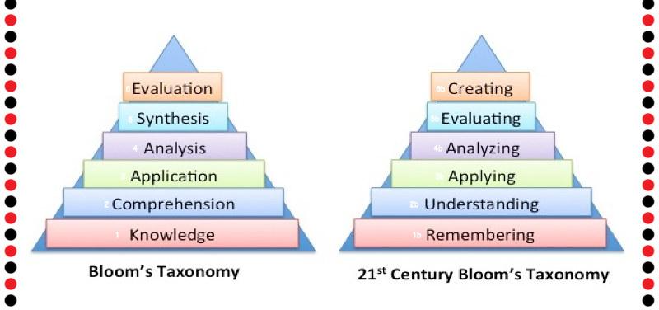

“If you know how to handle the verbs, you know how to handle the language. Everything else is just vocabulary”.

~ Michel Thomas ~

What is Bloom’s Taxonomy

Bloom’s Taxonomy is a classification of the different objectives and skills that educators set for their students otherwise known as learning objectives. The taxonomy was proposed in 1956 by Benjamin Bloom, an educational psychologist at the University of Chicago. The terminology has been recently updated to include the following six levels of learning. These 6 levels can be used to structure your learning objectives, lessons, and assessments.
Remembering: Retrieving, recognizing, and recalling relevant knowledge from long‐term memory.
Understanding: Constructing meaning from oral, written, and graphic messages through interpreting, exemplifying, classifying, summarizing, inferring, comparing, and explaining.
Applying: Carrying out or using a procedure for executing or implementing.
Analyzing: Breaking material into constituent parts and determining how the parts relate to one another and to an overall structure or purpose through differentiating, organizing, and attributing.
Evaluating: Making judgments based on criteria and standards through checking and critiquing.
Creating: Putting elements together to form a coherent or functional whole; reorganizing elements into a new pattern or structure through generating, planning, or producing.

Like other taxonomies, Bloom’s is hierarchical, meaning that learning at the higher levels is dependent on having attained prerequisite knowledge and skills at lower levels. You will see Bloom’s Taxonomy often displayed as a pyramid graphic to help demonstrate this hierarchy. We have updated this pyramid into a “cake-style” hierarchy to emphasize that each level is built on a foundation of the previous levels.

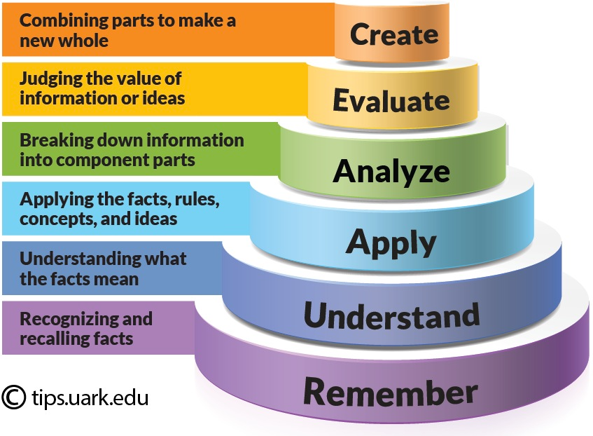

Citation: You may use this graphic for educational or non-profit use if you include a credit for Jessica Shabatura and a citation back to this website. The University of Arkansas TIPS, July 26, 2022.

ested materials and activities are in teal.

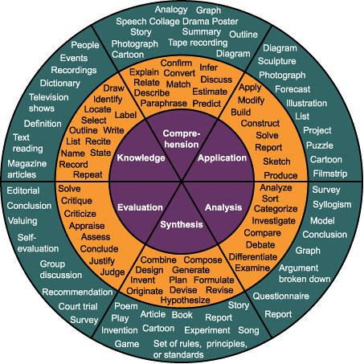

A more detailed verb chart can be found here, courtesy of the University of Arkansas:
https://tips.uark.edu/blooms-taxonomy-verb-chart/
The Vocabulary of Learning Screener

Student: _________________________________ Date: ________________

Grade: _________________________________ Age: ________________

Target Verb | Defined | Described | Sketched | Gestured
1
2
3
4
5
6
7
8
9
10
11
12
13
14
15

Target Verb | Defined | Described | Drew/Sketched | Gestured
16
17
18
19
20
21
22
23
24
25
26
27
28
29
30

Insert the target words you want to assess based upon the student’s age and/or grade level.

Then calculate the % of correct responses: __________________________

Form Created By: Gina England MA, CCC-SLP

Assessing Pre-Verbal Skills:

A Motor to Oral Imitation Hierarchy:

- Actions with objects - child copies things you do with toys
- Gestures - symbolic representation of words: waving, pointing, blowing kisses
- Facial expressions - exaggerated mouth movements, sticking tongue out
- Intentional vocalizations - making sounds directly to someone about something
- Sound words - mmmm, bang, boom, crash, yay, ouch, boo, whoa, whee
- Verbal routines/fill in the blank - ready, set ___, up and ___, in and ___
- Power words - no, mine, yes, help, stop, more, eat, drink, open, my
- Single words - words that have high relevance to the child and are relatively easy to pronounce

The above hierarchy does not apply to Gestalt Language Processors - specifically, some children on the Autism Spectrum.

An Imitation Hierarchy for Gestalt Language Processors:

- Delayed echolalia
- Partial gestalts- partial portions of a frequent verbal script
- Original or novel single words
- Novel 2- word combinations
- Original phrases

Citation: Solid Foundations: 10 Key Pre-Verbal Skills for Language Development. Online webinar hosted by AbleNet and presented by Kelli Meyer, CCC-SLP @TheSpeechScoop, 09-03-2024.

Informal Assessment Measures - Early Intervention

Name of Measure | Cost | Age Range | Targeted Skills
Hawaii Early Learning Profile (HELP)  https://shineearly.store/products/help-0-3-essential-set-1 | $ 165.00  checklist | 0 – 3 years  3 - 6 years | Cognition, communication, fine motor, gross motor, social emotional, adaptive/self help skills.
ASHA Communication Developmental Milestones  https://www.asha.org/public/developmental-milestones/communication-milestones/ | Free | Birth to 5 years | Receptive and expressive language, speech sound acquisition, social skills
Child Development Inventory  https://static1.squarespace.com/static/562e8e0ae4b09db47d931eb9/t/565cd590e4b0c6e18e583427/1448924560903/cdi+manual.pdf | Free | 6 – 72 months | Self-help, gross motor, fine motor, social, language comprehension, expressive language, letters, and numbers.

Authentic Assessment With Pre-Schoolers

https://www.youtube.com/watch?v=Jw3LDD0KMno (show)

The Assessment Environment:

Gina’s Speech Therapy Play Room:

- Soft lighting
- Carpeting
- Areas were set up in a fashion similar to Pre-K and Kindergarten “centers”
- Tool bench
- Doll house
- Bucket of vehicles, road map rug, parking garage, car ramp
- The kitchen - fridge, stove, oven, barbeque grill, hand mixer, toaster
- Lots of varied food items stored by category (fruit, veggies, breads, desserts, sandwich ingredients, breakfast)
- A kid favorite - the drip coffee maker - allowed them to actually make drinkable drinks with instant decaf coffee (for the staff), Nestle chocolate and strawberry Quick, decaf ice tea
- Sensory table with various content - fish tank pebbles, sand, rice
- Musical instruments
- Cash register
- Trains and train tracks
- Bubbles
- A talking alphabet and vocabulary board

- The opportunities for vocabulary targets were varied and took into account the different activities children will choose when engaging in play.
- The materials for the playroom were obtained through a preschool grant and donations of gently used toys from staff and parents.
- An unexpected outcome - the older elementary students requested time in the playroom!
- The playroom became a place where students could visit for a “brain break”, a reward for regulating their behavior in the student support center and a motivator to complete classroom assignments. “Free time” in the playroom was typically 5-15 minutes, depending on the individual situation.
- Older students enjoyed playing with our preschoolers and it became a non-threatening way to work on their social pragmatic skills. They were encouraged to be good role models for the younger children by engaging in cooperative, interactive play.

Informal Assessment Measures - Preschool

Revised Knox Preschool Play Scale
- The Revised Knox Preschool Play Scale (KRPPS) is not a standalone product but is found within the manual Play in Occupational Therapy for Children, 2nd Ed..
- $75-80
- Birth to 6 years
- Using play behavior to assess gross motor, interest, fine motor, attention, motor imitation, participation, cooperation, humor and language skills

Sampling Utterances and Grammatical Analysis - Revised (SUGAR)

https://www.sugarlanguage.org/downloads

- Free
- 3-11 years
- Calculating Mean
- Length of Utterance (MLU) from a 50-utterance sample.
- Analyzing gramma-tical forms and structures.

Brown’s Stages of Expressive Language Development
https://www.handyhandouts.com/viewHandout.aspx?hh_number=561&nfp_title=Brown%e2%80%99s+Stages

- Citation: Superduper Inc.
- Free
- 12-46 months
- Expressive Language Development

Language Severity Rating Scale

https://www.tn.gov/content/dam/tn/education/special-education/eligibility/se_speech_or_language_impairment_evaluation_guidance.pdf

- Free
- Any age
- Vocabulary
- Syntax
- Semantics,
- Morphology
- Pragmatics

Sentence Diversity Priming Task

http://bit.ly/sdpt-tool

- Free
- 30-48 months
- A dynamic assessment format - what are children capable of with some guidance utilizing graduated prompting.
- Offering a more accurate picture of their language learning potential.
- The task takes the form of an interactive animated storybook on a device and is designed to assess sentence diversity in young children. The adult and child take turns describing the actions of animated characters and objects.
- Scoring is based upon the level or degree of prompting required.

Citation: Krok, Windi. “Developing Tools That Reveal Children’s True Language Progress”, The ASHA LEADER, page 62, July/August 2025.

Play and Social Development Charts

https://childdevelopment.com.au/resources/child-development-charts/play-and-social-developmental-charts/

- Free
- 0 months through 7 years
- Developmental milestones for play skills and social development.
- It also includes the possible implications if the milestones are not achieved.

Citation: Kids Sense Speech and Occupational Therapy Centers across Australia.

Demonstration: The Binder of Assorted Developmental Norms

Informal Assessment Measures Review

General Skill Development:

Functional Communication Profile
https://www.proedinc.com/Products/34040/fcpr-functional-communication-profilerevised.aspx
- $90
- 3:0-Adult
- Sensory-motor, attention, receptive/expressive language, social pragmatics/communication, speech, voice, oral motor, fluency, non-verbal communication

Super Duper Speech and Language Screener
https://www.superduperinc.com/media/pdf/forms/TA160.pdf
- Free to use as is, but the Quick Take Along Mini Book of Pictures is extra($10.98)
- 3-8 years
- Articulation, early concepts, simple directions, complex directions, WH questions, vocabulary, categories, grammar, phonological awareness, auditory memory, story retell, sequencing, listening comprehension, inference, speech sample, social skills.

Speech Participation and Activity Assessment of Children (SPAA-C)
https://cdn.csu.edu.au/__data/assets/pdf_file/0011/2761571/SPAA-C-Questions-English.pdf
- Free
- Age 3 years and above
- SPAA-C originally was developed to provide speech-language pathologists with information about children with speech sound disorders but may also be relevant for considering children's communication more broadly (e.g., with children who are multilingual, children who stutter, children who have language disorders, children with hearing loss). The questions can be adapted to suit the context and are available in 8 languages.

What’s Your Learning Style Student Survey
https://pa01916442.schoolwires.net/cms/lib/PA01916442/Centricity/Domain/1138/Affective%20Ed%20Lessons.pdf
- Free
- Grades 6-12
- Assists in determining if your student’s preferred learning style is visual, auditory, kinesthetic or mixed. Additional more in-depth surveys are included.
Citation: Jonni Kincher. “What’s Your Learning Style”? Psychology for Kids. Free Spirit Publishing, 1995.

Apraxia

Debbie’s 10 Long Clinically Useful Words
https://www.speech-language-therapy.com/pdf/djwordsCLR2pp.pdf
- Free
- Grades K-12
- Multi-syllabic words with illustrations.

Dysarthria/Apraxia Screening
https://synergycare.com/downloads/standardizedtests/ST%20-%20Dysarthria%20Screener.pdf
- Free
- Grades K-12
- Intelligibility, respiration, phonation, prosody, resonance, articulation.

Screening Test for Developmental Apraxia of Speech
Citation: Robert W. Blakeley PhD, copyright 1980, C.C.Publications Inc.
A discontinued product that is no longer available for sale. The original content included the following domains to be screened:
1. Vowels and Dipthongs: “You say what I say”
- Me-eat
- Hit-bit
- Head-bed
- Mad-cat
- Cop-mop
- Moo-you
- Book-look
- Dog-bought
- Mud-hut
- Hi-my-eye
- Now-out-cow
- Boy-toy-coy
- Way-hay-may
- Hoe-no-go
2. Oral Motor Movement: SLP models movement, child produces movement
- Stick your tongue out, like this
- Put your tongue on the corner of your mouth, like this
- Now put your tongue on the other corner, like this
- Put your tongue on your upper lip, like this
- Put your tongue on your lower lip, like this
- Put your tongue behind your upper teeth, like this
- Round your lips, like this
- Put your lips out like this, then pull them way back like this. Do this three times. The child must complete three sequences of lip protrusion-retraction.

3. Verbal Sequencing: “You say what I say”
- Ask the child to produce /p/, /t/ and /k/ in isolation

- Child is asked to repeat puh-tuh-kuh
- Child is asked to repeat kuh-tuh-puh
- Child is asked to repeat tuh-tuh-puh
- Child is asked to repeat puh-puh-tuh
- Child is asked to repeat kuh-kuh-tuh

- Puh-tuh-kuh puh-tuh-kuh puh-tuh-kuh
- Kuh-tuh-puh kuh-tuh-puh kuh-tuh-puh
- Tuh-tuh-puh tuh-tuh-puh tuh-tuh-puh
- Puh-puh-tuh puh-puh-tuh puh-puh-tuh
- Kuh-kuh-tuh kuh-kuh-tuh kuh-kuh-tuh

4. Articulation: Present test words orally in a sequence of three

Test Words | Sound | Initial | Medial | Final
mouse-hammer-come | m
nose-banana-man | n
house-doghouse | h
pie-apple-cup | p
cow-walking-cook | k
top-potato-cat | t
fork-coffee-knife | f
window-sidewalk | w
monkey-sing | ng
boy-rabbit-bib | b
girl-wagon-bag | g
dog-daddy-bed | d
yellow-onion | j
Santa-bicycle-miss | s
leaves-balloon-ball | l
rug-carrot-car | r
shoe-dishes-fish | ഽ
chicken-watching-peach | tഽ
jelly-soldier-cage | dჳ
thumb-bathtub-teeth | ፀ
zebra-scissors-eyes | z
Vicky-never-more | v
the-feather-smooth | ð
treasure-beige | ჳ

5. Motorically Complex Words: “Say the word just like I do”
- Aluminum
- Linoleum
- Statistics

6. Transpositions: “Say the word just like I do”

Stimulus | Actual Production
basket
hamburger
music
package
elephant
girl
hockey
difficult
horrible
plastic
accident
nose
Articulation

Name of Measure | Cost | Age Range | Targeted Skills
Create Your Own Screener (using google images) | Free | PK – 12th grade | Mine includes the following: consonants in all three positions of words, /s/ blends, /l/ blends, /r/ blends and /r/ controlled vowels
Quick Vowel Screener  https://speech-language-therapy.com/pdf/vowelscr2010.pdf | Free | PK – 12th grade | Production of vowels in spontaneous speech.  Includes color pictures.
Speech Characteristics Rating Scale  https://speech-language-therapy.com/pdf/scr.pdf | Free | PK-12th grade | Prosody, voice quality, resonance, pitch, loudness, rate and fluency.
Speech Sound Production Severity Rating Scale  https://www.tn.gov/content/dam/tn/education/special-education/eligibility/se_speech_or_language_impairment_evaluation_guidance.pdf | Free | PK-12th grade | Sound production, stimulability, oral motor sequencing, intelligibility.
Intelligibility in Context Scale  https://cdn.csu.edu.au/__data/assets/pdf_file/0008/408356/ICS-instructions-VERSION-1-November-2012.pdf | Free | Any Age | Speech intelligibility in assorted contextual interactions.  Available in many languages.
Diadochokinetic Syllable Rates Worksheet  https://chhs.fresnostate.edu/csds/documents/Diadochokinetic%20Syllable%20Rates%20Worksheet.pdf | Free | 6 – 13 years | Oral motor and articulatory precision.
Articulation Screener from Mommy Speech Therapy and Little Bee Speech  https://mommyspeechtherapy.com/wp-content/downloads/forms/articulation_screener.pdf | Free | 2-8 years | Quick screener including /r/, /l/ and /s/ blends. Color stimulus pictures are included.
Lingraphica Speech Apps  https://lingraphica.com/smalltalk-aphasia-apps/ | Free | PK-12th grade | Oral motor exercises, consonant blends, isolated consonants and vowels with video demonstrations of each skill set. Although originally designed for people with Aphasia, I have used them for years with my students.

Comprehension of Language

Name of Measure | Cost | Age Range | Targeted Skills
Formulaic and Novel Language Comprehension Test  https://danielkemplerblog.wordpress.com/familiar-and-novel-language-comprehension-test/ | Free | 3 – 80 years of age | Assesses formulaic (non-literal) and novel (literal) language forms at the sentence level. Normative data and pictorial stimuli are included.
School Age Language Assessment Measures (SLAM)  Understanding Spoken Stories  https://www.leadersproject.org/2015/12/03/slam-understanding-spoken-stories/ | Free | 5 years – 11 and above | Receptive and expressive language. The stories are organized by age groups and contain follow-up questions.
Kempler Sentence Comprehension Test  https://danielkemplerblog.wordpress.com/kempler-sentence-comprehension-testt/ | Free | Most appropriate for students aged 7 years and above | Performance is scored for accuracy of response and response time.

Verbal Expression

Name of Measure | Cost | Age Range | Targeted Skills
Student Language Scale (SLS)  https://products.brookespublishing.com/TILLS-Student-Language-Scale-SLS-P877.aspx | $35.00 | 6-18 years | Screening for a language/literacy disorder including Dyslexia. 12 questions.
Language Severity Rating Scale  https://www.tn.gov/content/dam/tn/education/special-education/eligibility/se_speech_or_language_impairment_evaluation_guidance.pdf  (direct link is on page 3-Appendix P) | Free | Any age | Vocabulary, syntax, semantics, morphology, pragmatics.
Word Finding Referral Checklist - Second Edition  http://www.wordfinding.com/classroomobservations.html  Error Pattern 1- Semantic Errors  Error Pattern 2- Retrieval Errors  Error Pattern 3- Phonologic Errors | $30.00 | Any age | 15 questions to ask parents and/or teachers when a word finding problem is suspected in a student.
Language Sampling:  Wordless Picture Books  Graphic Novels | Varies  Varies | Grades 1-6  Grades 7-12 | Record student’s performance and analyze linguistic forms and content.
Social Pragmatics

Name of Measure | Cost | Age Range | Targeted Skills
Pragmatic Language Observation Scale (PLOS)  https://www.proedinc.com/Products/12875/plos-pragmatic-language-observation-scale.aspx | $64.00 | 8 years – 17 years, 11 months | Assesses student’s daily classroom spoken language behaviors.  Norm referenced.
Pragmatic Language Skills Inventory  https://www.proedinc.com/Products/11365/plsi-pragmatic-language-skills-inventory.aspx | $148.00 | 5 years through 12 years 11 months | Personal interaction, social/class skills.  Norm referenced.
Social Communication Skills – The Pragmatics Checklist  https://successforkidswithhearingloss.com/wp-content/uploads/2013/06/PRAGMATICS-CHECKLIST2.pdf | Free | 24-60 months | States needs, gives commands, expresses feelings, interaction, seeks explanations, shares thoughts and knowledge. Can also be used with hearing impaired children.
Prutting Pragmatic Protocol  https://www.childpsychology.com/training/prutting.pdf | Free | 5 years of age and above | Verbal Acts, Paralinguistic Aspects, Non-verbal Aspects
R-G Middle High School Social Skills Rubric  https://docs.google.com/document/d/1dzskSmrKSc5QayhE08VGaKhn3cRdcmNE/edit | Free | Grades 7-12 | Conversational skills  Listening Skills Peer-Frendship Skills Interactions with Adults Self Regulation Conflict Management
Social Language Screener: Elementary and Adolescent Versions  https://www.teacherspayteachers.com/Product/Social-Language-Screener-BUNDLE-7234189  Show Preview | $10.00 | Elementary and Adolescent Students | Elementary:  Identifying Emotions,Perspective Taking, Body Language, Conversations, Social Inferences,Problem Solving, Figurative Language.  Adolescent:  Emotions, Multiple Perspectives, Body Language, Conversations, Social Inferences, Awkward Situations, Complex Problems, Figurative Language, Sarcasm, Humor, Voice.

Autism

Name of Measure | Cost | Age Range | Targeted Skills
VB-MAPP Protocol - Intraverbal Assessment Subtest  https://avbpress.com/shop/vb-mapp-protocol/  Instructions: https://avbpress.com/wp-content/uploads/2019/07/F-Intraverbal-sub-test-instructions.doc | $40.00 | 0-48 months  Separated into three age levels | An effective way to determine the learning, language, and social skills of children with developmental delays such as Autism. It provides a behavior-based language assessment, curriculum guide, and skills-tracking program. The VB-MAPP is criterion-referenced and field-tested against typically developing children and children with Autism. This means it measures how well a child performs compared to an objective rather than another child. The assessment and guide provide a baseline level of the language and social skills of a child with Autism or developmental delays, while also examining their learning style.
Autism Communication Screeners from ABA Speech  Get the screeners here. | Free | Preschool Screener  School Age Screener  Advanced Language Screener  General Communication  Observations | Social Engagement, Requesting, Matching, Play, Following Directions, Labeling, Imitation, Spontaneous Communication.  General Communication, Social Engagement, Requesting, Matching, Play, Following Directions, Labeling, Imitation, Spontaneous Communication.  General Communication, Expressive Language, Grammatical Markers, Vocabulary, Comprehension.  Following Directions, Social Language, Speech Clarity.  Lunch and Recess Small Group Academic Class Large Group Academic Class A Specials Class (art, music, PE etc.)

Fluency

Name of Measure | Cost | Age Range | Targeted Skills
Fluency Severity Rating Scale  https://www.tn.gov/content/dam/tn/education/special-education/eligibility/se_speech_or_language_impairment_evaluation_guidance.pdf  (The link is on page 3 - Appendix R) | Free | Any Age | Frequency and description of dysfluency, rate of speech
Dysfluency/Fluency Checklist  https://www.tn.gov/content/dam/tn/education/special-education/eligibility/se_speech_or_language_impairment_evaluation_guidance.pdf  (The link is on page 3 - Appendix H) | Free | Any Age | Frequency, Rate of Speech, Avoidance Situations, Environments, Type of Dysfluency, Academic and Social Impacts
Fluency Questionnaire for Parents and Caregivers  https://www.tn.gov/content/dam/tn/education/special-education/eligibility/se_speech_or_language_impairment_evaluation_guidance.pdf  (The link is on page 3 - Appendix K) | Free | Any Age | Speech Concerns, Age of Onset, Medications, Dysfluency Observations, Changes in the Home, Family History, Situations Likely to Result in Symptoms.

Perceptions of Stuttering Inventory  https://csd.uncg.edu/wp-content/uploads/2023/12/2.D._1.perceptions_of_stuttering_inventory1.pdf | Free | Grades 6-12 | 60 statements about stuttering. Read each item carefully and respond by placing a check mark in the square if the item describes you. Each characteristic refers only to what you do now. Even if the behavior described occurs only occasionally or only in some speaking situations, if you regard it as characteristic of your stuttering, place a check mark in the square.

Voice

Name of Measure | Cost | Age Range | Targeted Skills
Voice Severity Rating Scale  https://www.tn.gov/content/dam/tn/education/special-education/eligibility/se_speech_or_language_impairment_evaluation_guidance.pdf  (Link is on page 3 - Appendix S) | Free | Grades K - 12 | Pitch, Intensity, Quality, Resonance
Voice Checklist  https://www.tn.gov/content/dam/tn/education/special-education/eligibility/se_speech_or_language_impairment_evaluation_guidance.pdf  (Link is on page 3 - Appendix L) | Free | Grades K-12 | Vocal Quality, Impact on Communication, Excessive Vocal Behaviors, Frequency, Social or Emotional Impact

Pediatric Voice Handicap Index  https://baysidevoicecentre.com.au/wp-content/uploads/2021/04/BVC-Paed-Voice-Handicap-Index-formonly.pdf | Free | 3-18 years | Functional, physical and emotional aspects of voice are rated on a numerical scale. This allows the therapist to determine a severity rating and identify potentially related factors.

Phonological Awareness

FOM Name | Cost | Age Range | Targeted Skills
Phonological Awareness Skills Screener (PASS)  https://www.seniainternational.org/wp-content/uploads/2011/02/PASS-directions.pdf | Free | K through Second Grade. Can also be used with older students who are experiencing difficulty developing phonological awareness. | Discrimination, rhyming, blending, segmentation, syllable deletion, phoneme recognition
Access to Literacy Assessment System-Phonological Awareness (ATLAS-PA)  https://accesstoliteracy.com/ | Free | 3-7  years | Software Program.  Relies entirely on receptive responses not verbal (by-passes the presence of a speech and language disorder as a barrier to testing).
Phonological Awareness Profile  https://www.proedinc.com/Products/34090/the-phonological-awareness-profile.aspx | $ 49.00 | K through 12th Grade | Rhyming  Segmentation  Isolation  Deletion  Substitution  Blending  Graphemes:  (consonants, long and  short vowels, vowel  teams/diagraphs,  diphthongs, controlled  vowels, consonant  diagraphs, consonant  blends.  Decoding single words  with the above stated  graphemes.  Invented Spelling Stage

Create an Informal Assessment Binder or a Digital Equivalent

Suggestions For Binder Section Headings or Digital Folders:

- Apraxia
- Articulation
- Auditory Skills
- Autism
- Early Intervention
- Ell/ESOL
- Executive Functions
- Fluency
- General Skill Development
- Language - Comprehension
- Language - Expression
- Phonology
- Play
- Preschool
- Screenings
- Social Skills
- Speech
- Voice

Additional Materials to be Kept in the Binders or Your Digital Folders:

- Developmental Milestones
- A wordless book
- A graphic novel
- Frequently used normative data
- Data collection forms
- Any required user names/passwords to access the informal measures
- A calendar with good illustrations for language stimulation
- Multiple copies of each informal measure
- Related rubrics
- Print required test materials

Factors That May Disrupt the Assessment Process:

- Sleep deprivation
- Dehydration
- Poor nutrition
- Food Insecurity
- Inactivity
- Stress
- Trauma

Likely Causes of the Increase in Behavioral Dysfunction Among Our Students:

- Social and lifestyle changes – solo and indoor play
- The increase in reported and unreported concussions
- The smart phone dilemma – external vs. internal frontal lobes
- Under reporting of childhood trauma
- The natural results of the loss of the “nuclear family”
- Environmental contaminants in our air, soil and water
- Unknown pre-natal exposure to drugs and/or alcohol
- Fluctuating high or low blood sugars due to food insecurity

The Impact of Executive Dysfunction on Behavior in the School Environment:

- problems initiating and completing work
- slower and often ineffective speed of work
- impaired auditory and visual processing of academic information
- poor organization of notebooks, assignments and homework
- impulsive response patterns
- decreased productivity
- confusion/misinterpretation of expectations resulting in increased stress
- difficulty generalizing new learning into other situations/environments
- distractibility
- cognitive fatigue
- disruptive behaviors in the classroom
- increased need for behavioral interventions

Mitigating Challenging Behaviors During the Evaluation Process:

- Prior to the start of testing, identify the student’s personal areas of interest and begin your evaluation with a short conversation about a particular topic. Not only will it facilitate rapport, it will allow the student to feel more relaxed at the onset as they answer your questions about a familiar and favored topic.
- Prior to the evaluation, do a Google or AI search for vocabulary related to the student’s preferred interest, and generate a list of words that could be incorporated into your assessment. Can they define the word? Can they use it accurately in a sentence? Can they identify a synonym or an antonym?
- Ask the student to verbalize a summary (“tell me everything you know about ___”) of their preferred topic eg. Trains, WW2, Galapagos Turtles, Taylor Swift etc. in order to obtain an oral narrative sample. Record the sample on your phone for analysis later on. Always tell the student they are being recorded and that you will erase the recording after you have listened to it later on.
- I have always found it interesting to do an oral narrative sample for a preferred and non-preferred topic to see the similarities or differences in language forms and content. They should be somewhat familiar with the non-preferred topic (something they are currently learning about in the classroom).
- Do sensory checks during your sessions - are they hot, cold, hungry, thirsty? (I always keep snacks and drinks in my speech therapy room as hunger is a real issue for my students).
- Do they need a movement break?
- Set a timer on your phone to visually count down the opportunity for the next break
- Reduce the amount of time spent during “formal testing” by utilizing multi-disciplinary rating scales
- Obtain assessment data from multiple sources: Classroom Teacher, Special Education Teacher, Paraprofessional or Instructional Aide, OT, PT, Unified Arts Teachers (more on this later).
- This aligns well with the Authentic Assessment Model
- Consider the art of negotiation - allow the older student to participate in the terms of your assessment. I have written down the terms and have had both of us sign or initial the paper.
- I try to avoid the use of “rewards”. I prefer to frame it as “personal choice time” and encourage activity-based choices versus food or objects.

Resources to Locate Additional Informal Assessment Measures

Video Assessment Tests: slpplatform.com

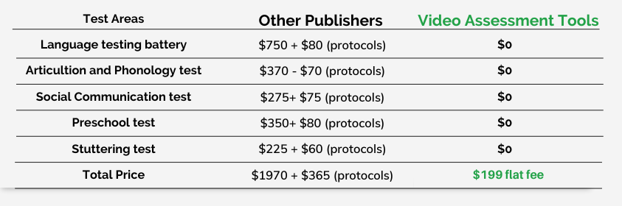

- Also includes Rating Scales for Articulation, Language, Social Communication
Preschool and Stuttering.
- Also includes the opportunity to purchase Social Communication and
Stuttering Therapy Programs.
- Also includes free CEUs and Professional Development webinars

~~~~~~~~~~~~~~~~~~~~~~~~~~~~~~~~~~~~~~~~~~~~~~~~~~~~~~~~~~~~~~~~~~~~~~

Free Language Sample Checklist:
https://www.teacherspayteachers.com/Product/FREE-Language-Sample-Checklist-Informal-Assessment-Speech-Therapy-7211228

~~~~~~~~~~~~~~~~~~~~~~~~~~~~~~~~~~~~~~~~~~~~~~~~~~~~~~~~~~~~~~~~~~~~~~

Free SLP Assessments from Caroline Bowen PhD, SLP includes the following:

- A Quick Test of Articulation and Phonology
- A Quick Vowel Screener
- Speech Characteristics Rating Form
- Stimulability Assessment
- The ALPHA Test of Phonology
https://www.speech-language-therapy.com/index.php?option=com_content&view=article&id=11&Itemid=117

~~~~~~~~~~~~~~~~~~~~~~~~~~~~~~~~~~~~~~~~~~~~~~~~~~~~~~~~~~~~~~~~~~

Assessment of Speech Sound Production: A Resource Packet
http://impactofspecialneeds.weebly.com/uploads/3/4/1/9/3419723/assessment_of_speech-_sound_production.p
Sound development
Sound development charts for females and males
Vowel development
Extinction of phonological processes
Words/phrases to assess sound stimulability by age
Limb-oral-verbal apraxia screenings
The Dysarthrias – symptoms of each classification
Cleft Palate speech

~~~~~~~~~~~~~~~~~~~~~~~~~~~~~~~~~~~~~~~~~~~~~~~~~~~~~~~~~~~~~~~~~~

Normative Data:
https://www.tn.gov/content/dam/tn/education/special-education/eligibility/se_speech_or_language_impairment_evaluation_guidance.pdf
Articulation Norms
Phonological Processing Norms
Language Milestones

~~~~~~~~~~~~~~~~~~~~~~~~~~~~~~~~~~~~~~~~~~~~~~~~~~~~~~~~~~~~~~~~~~~~~~~~

Test Prep Review: https://www.testprepreview.com/
Online Practice Tests > K-12 > Common Core Practice Test/ HSPT/ Iowa Assessments/ PARCC

Thanks for joining us today

